**APPLICATION FOR FIREARMS ENDORSEMENT**

**DETAILS OF APPLICANT**

|  |  |  |  |  |  |
| --- | --- | --- | --- | --- | --- |
| **Full Name:** |  | | | | |
| **SAMSSA**  **No:** |  | | **ID Number** | |  |
| **Contact  Details** | **Cell** |  | | **Email** |  |

**DETAILS OF FIREARM**

|  |  |  |  |  |  |
| --- | --- | --- | --- | --- | --- |
| **Type** (eg. Pistol) | **Calibre** (eg. 22LR) | **Make & Model** (e.g. Anschutz Model 1432D) | | **Serial Number on Frame** | **Serial Number on Barrel** |
|  |  |  | |  |  |
| **Technical Data** | | | | | |
| Overall Length | Barrel Length | Weight | Other (as applicable) | | |
|  |  |  |  | | |

**PURPOSE**

|  |
| --- |
| **Please explain in this section for which item(s) did you procure this firearm for** |
|  |

**DECLARATION BY APPLICANT** (please complete this section in own handwriting in pen, no electronic signatures will be allowed)

I, _______________________________________________ ID _______________________ applies for the above mentioned endorsements and solemnly declare the following:

* That all of the above information is correct
* That I intent to regularly participate in the Metallic Silhouette Shooting Sport at club and/or provincial level
* That I intend to use the firearms for which I am requesting endorsements in this application to participate in club and/or provincial competitions
* That I intend to renew my membership with SAMSSA annually before 31 December each year
* That I have been issued with a relevant and valid firearm competency certificate issued by the South African Police Services.
* That I am not aware of any reason why the requested endorsement(s) should not be issued to me.

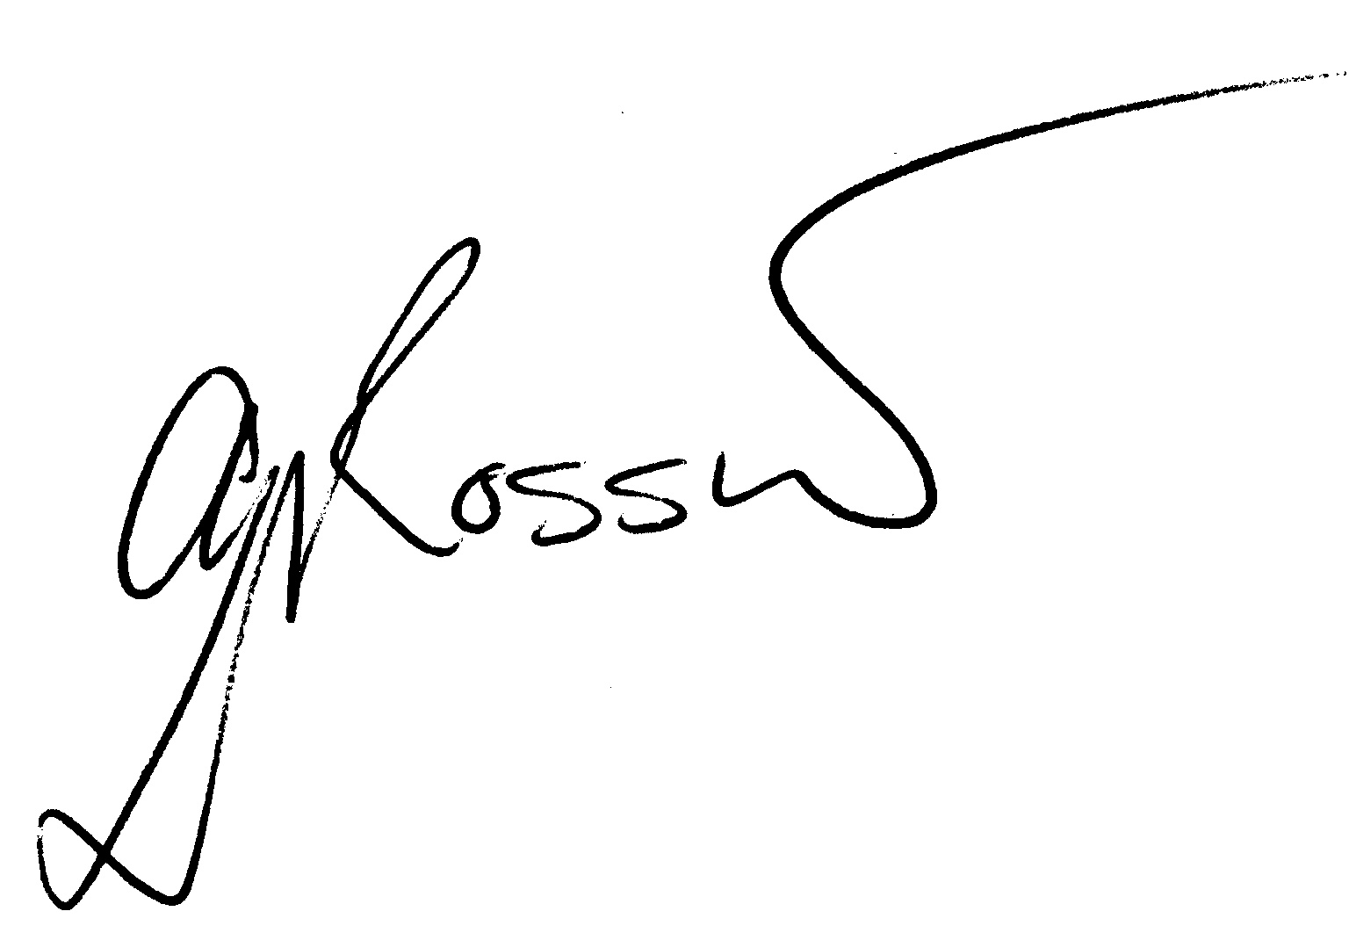 Signature: ________________________________________ Date: _______________________

|  |
| --- |
| Please submit application to  [secretary@samssa.org.za](mailto:secretary@samssa.org.za) or SAMSSA or FAX: 086 670 5337  PO Box 31165  Fichardtpark  9317 |

|  |
| --- |
| Please attach photo of relevant firearm |
|  |